|  |
| --- |
|  |

*An Update on the Main Street Project*

[BREVARD, N.C., March 21, 2023] – We are thrilled with the speed and efficiency with which Sossamon Construction is working to implement the new improvements on Main Street. The crews have already completed much of the initial demolition on the north side of Main Street and are preparing to move on to the next phase. While the day-to-day details of construction work are always subject to change, depending on variables like weather, workflow, material availability, and so forth, the following is a tentative schedule of what the public can expect to see over the next two weeks:

* 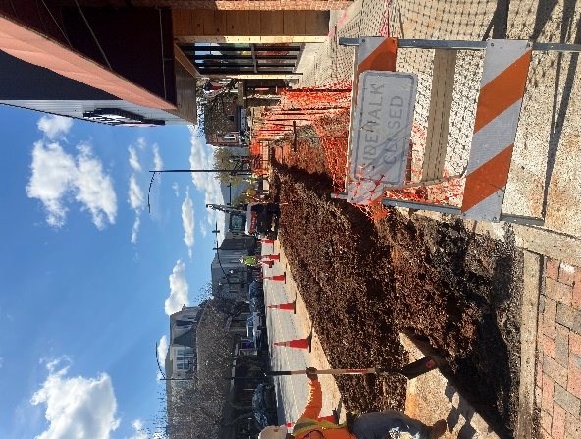Primary sidewalk demolition will continue on the north side of Main Street through March 24. During this period, the sidewalk will be narrower in some sections but will not be closed entirely. All storefronts will remain accessible unless they state otherwise.
* Boring and sleeving will take place along with demolition phases during the last week of March.
* Starting April 3, portions of the sidewalk on the north side of Main Street will undergo temporary total closures during the final phases of demolition and reconstruction. People will still be able to enter local businesses in these areas via temporary ramps.
* Once the gutters, trench drains, and curb extensions have been completed on the north side of Main Street, Sossaman will repeat the demolition and construction process on the south side of Main Street.

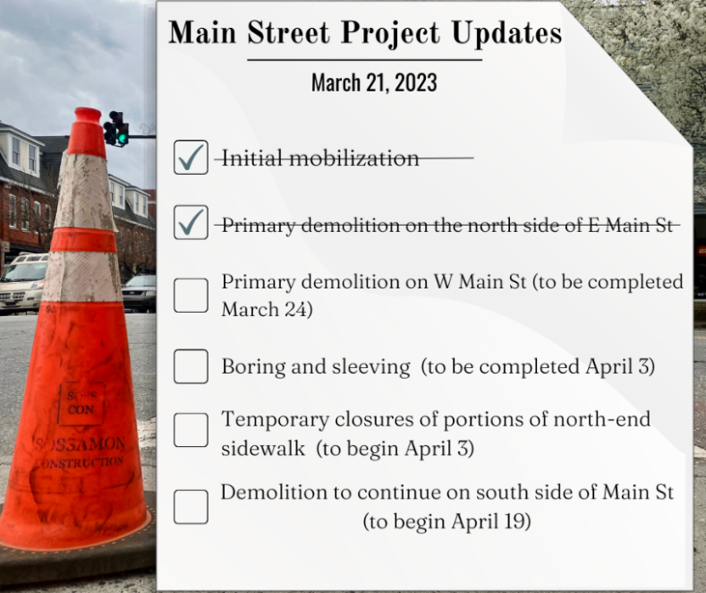We are grateful to the Heart of Brevard for working with downtown businesses to ensure minimum disruption during this phrase of the Main Street Project. The Heart of Brevard also plans to install signage downtown that publicizes construction updates. People visiting downtown should expect to start seeing closures the first week of April, and the City will continue to publish updates and information about any additional changes to sidewalk traffic as they occur. Motorists and pedestrians should continue to exercise caution near construction zones.

|  |
| --- |
| Complementary Projects   * Underground water + sewer upgrades and utility maintenance   (winter 2022, spring 2023—water complete, sewer underway)   * NCDOT milling and repaving of Main St   (late summer 2023) |